Министерство науки и высшего образования РФ

ФГБОУ ВО «Нижневартовский государственный университет»

Факультет информационных технологий и математики

Кафедра информатики и методики преподавания информатики

**Отчет по лабораторной работе № 2**

**по дисциплине "ЭВМ и периферийные устройства"**

**Вариант №9**

**Выполнил:**

студент группы 3312

Лысенко О.Е

**Проверил:**

r.п.н., доцент,

доцент кафедры ИМПИ

Манюкова Наталья Владиславовна

Нижневартовск, 2025

**Тема: Организация ЭВМ**

**Задание: Выполнить инструкции в регистрах, используя мнемокоды команд. Вариант 9**

**Ход выполнения работы:**

**Мнемокоды - коды:**

**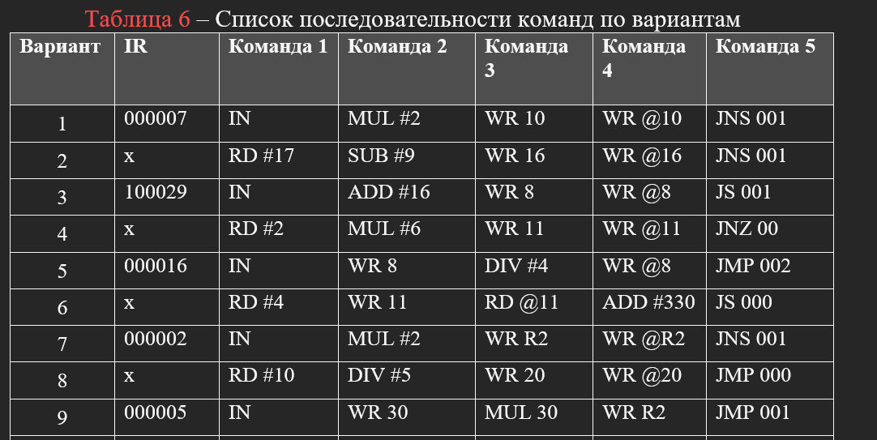  
Таб 3.**

| **Адрес** | **Мнемокод** | **Код** | **Примечания** |
| --- | --- | --- | --- |
| **000000** | **IN** | **010000** | **Ace ← IR** |
| **000001** | **WR 30** | **220030** | **M30 ← Acc** |
| **000002** | **MUL 30** | **250030** | **Acc ← Acc 30 DD** |
| **000003** | **WR R2** | **320002** | **R2 ← Acc** |
| **000004** | **JMP 1** | **100001** | **PC ← CR[ADR]** |

**Е  
Таб 4.**

**Зафиксировать изменение программно доступных объектов:**

| **PC** | **Acc** | **M30** | **R2** |
| --- | --- | --- | --- |
| **000** | **000000** | **000000** | **000000** |
| **001** | **000005** |  |  |
| **002** | **000025** |  | **000005** |
| **003** | **000025** |  |  |
| **004** |  |  | **000025** |

**Таб 5.**

| **Адрес PC** | **Мнемокод** | **Микрокоманда** | **ОЗУ** | **CR** | **АУ** | **Ячейки** | **ADR** | **Acc** | **DR** | **030** | **R2** |
| --- | --- | --- | --- | --- | --- | --- | --- | --- | --- | --- | --- |
| **MAR** | **MDR** | **COP** | **TA** |
| **000** | **IN** | **MAR:=PC** | **000** | **000000** | **00** | **000000** | **000** | **000000** | **000000** |  | **000000** |
|  |  | **MRd** |  | **010000** |  |  |  |  |  |  |  |
|  |  | **CD:=MDR** |  |  | **01** |  |  |  |  |  |  |
|  |  | **PC:=PC+1** |  |  |  |  |  |  |  |  |  |
|  |  | **Acc:=IR** |  |  |  |  |  | **000005** |  |  |  |
|  |  | **END_COMAND** |  |  |  |  |  |  |  |  |  |
| **001** | **WR030** | **MAR:=PC** |  |  |  |  |  |  |  |  |  |
|  |  | **MRd** | **001** | **010000** | **01** |  |  | **000005** |  |  |  |
|  |  | **CD:=MDR** |  | **220030** |  |  |  |  |  |  |  |
|  |  | **PC:=PC+1** | **001** |  | **22** |  | **030** |  |  |  |  |
|  |  | **MAR := ADR** | **030** |  |  |  |  |  |  |  |  |
|  |  | **MDR := Acc** |  | **000005** |  |  |  |  |  |  |  |
|  |  | **MWr** |  |  |  |  |  |  |  |  |  |
|  |  | **END_COMMAND** |  |  |  |  |  |  |  |  |  |
| **002** | **MUL 30** | **MAR:=PC** |  |  |  |  |  |  |  |  |  |
|  |  | **MRd** | **002** | **250030** |  |  |  |  |  |  |  |
|  |  | **CD:=MDR** |  |  | **25** |  |  |  |  |  |  |
|  |  | **PC:=PC+1** |  |  |  |  |  |  |  |  |  |
|  |  | **MAR := ADR** |  |  |  |  |  |  |  |  |  |
|  |  | **MRd** | **030** | **000005** |  |  |  |  |  |  |  |
|  |  | **DR := MDR** |  |  |  |  |  |  |  |  |  |
|  |  | **ALU <-- COP** |  |  |  |  |  |  | **000005** |  |  |
|  |  | **Start ALU** |  |  |  |  |  | **000025** |  |  |  |
|  |  | **END_COMMAND** |  |  |  |  |  |  |  |  |  |
| **003** | **WR R2** | **MAR:=PC** |  |  |  |  |  |  |  |  |  |
|  |  | **MRd** | **003** |  |  |  |  |  |  |  |  |
|  |  | **CD:=MDR** |  | **320002** |  |  |  |  |  |  |  |
|  |  | **PC:=PC+1** |  |  | **32** |  | **002** |  |  |  |  |
|  |  | **RAR := CR5** |  |  |  |  |  |  |  |  |  |
|  |  | **RDR := Acc** |  |  |  |  |  |  |  |  |  |
|  |  | **RWr** |  |  |  |  |  |  |  |  |  |
|  |  | **END_COMMAND** |  |  |  |  |  |  |  |  |  |
| **004** | **JMP 001** | **MAR:=PC** |  |  |  |  |  |  |  |  |  |
|  |  | **MRd** | **004** |  |  |  |  |  |  |  |  |
|  |  | **CD:=MDR** |  | **100001** |  |  |  |  |  |  | **000025** |
|  |  | **PC:=PC+1** |  |  | **10** |  | **001** |  |  |  |  |
|  |  | **PC := ADR** |  |  |  |  |  |  |  |  |  |
|  |  | **END_COMMAND** |  |  |  |  |  |  |  |  |  |